What happens when you hit [www.scaler.com](http://www.scaler.com) google.com

1. Cache resolution
   * 1. 4 cache resolutions

(Incognito/vpn mode avoids browsers cache)

1Browser

* 1. OS(RAM)
  2. Router cache
  3. ISP

1. Make a call to DNS server
2. **ICAN(central repository for the domain and all IP address), GoDaddy etc are brokers they provide static ip address with name.**
   1. [www.scaler.com(recursive](http://www.scaler.com(recursive) server)

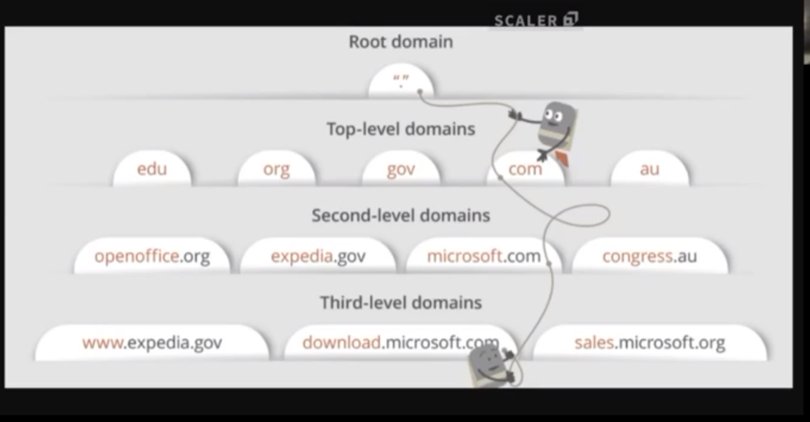

1. Make a connection between servers
   1. Three way handshake
   2. Send a syn package to the server for checking open connection
   3. Return Syn/Ack package if it is open to connection
   4. Return an ack packet after receiving you syn/ack packet
2. The browser sends an HTTP request to the webserver.
   1. https://miro.medium.com/max/1400/0*SyxEqHOBZElX5laf.png
3. The server handles the request and sends back a response.
4. The server sends out an HTTP response.
   1. [https://miro.medium.com/max/1400/0*ifRt45gihG_AwR3Z.png](https://miro.medium.com/max/1400/0*ifRt45gihG_AwR3Z.png)
   2. 1xx - information
   3. 2xx - Success
   4. 3xx - Redirection
   5. 4xx - Error on the clients part
   6. 5xx - Server related issues
5. HTML served to the browser

HTML

HEAD BODY

Script MEta  DIv DIv

P

What happens when a script is encountered

Script is a block rendering call

<script src=”https/js.com” > </script>

Async and defer

<script src=”https/js.com”  async> </script>

<script src=”https/js.com”  defer> </script>

<link href=”https/css.com”> </link>

HTML css

HEADcss BODYcss

Script css MEta css  DIvcss DIvcss

Pcss

PUMA  
NGINX  
LOAD Balancer

Cloudfront - CDN